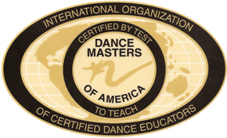

Dance Masters of America, Inc.
Transfer of Membership Form

TO BE COMPLETED AND MAILED BY THE MEMBER

Name of Member___________________________________________ Date__________________

Address__________________________________________________________________________

City_____________________________________________ State_______ Zip Code_________

Phone: Home_________________________________Cell________________________________

Email__________________________________________________

I am a: ___Certified Active/CE ___Honorary Certified Active/CE ___Professional/CE

___Degreed/CE ___Life

I am certified by test to teach in the following subjects ____Ballet ____Jazz ____Tap

____Modern _____Acrobatics

I wish to transfer my DMA Membership from Chapter # ________ to Chapter # ________

My reason for transfer is ____________________________________________________________

________________________________________________________________________________

________________________________________________________________________________

________________________________________________________________________________

I have paid my National Dues through August 31st 20________ through Chapter # ________

I have paid my Chapter Dues and Assessments through August 31st 20______ to Chapter # _______

I hereby state that I am a member in good standing and have no past or pending
disciplinary actions against me.

____________________________________________ _____________________
Signature of Member Date Mailed

Mail this form to:

Dance Masters of America
C/O Ruby Toy
21 Edison Drive
Huntington Station, NY 11746
Telephone: 516-250-8503

